

Modular Computer Vision System

Prepared for
Dr/ Mahmoud Gamal
Professor, Faculty of Computing And
Data science Alexandria university

By

Name | ID
Mesk Khaled | 23011537
Shahd Fawzy | 23012087
Ahmed Mohamed Shaaban | 23011213
Moaaz Salama | 23012085

May
2026

Introduction
- This project develops a modular computer vision system for image processing and enhancement.
- The system is designed in a Jupyter notebook using Python and common computer vision libraries.
- The main objective is to create reusable processing steps that can be applied to different images and extended to future tasks.
- The project focuses on combining classical image processing techniques such as color masking, sharpening, blurring, and blending.
- The overall workflow is built to be simple, flexible, and easy to modify for additional computer vision experiments.

Project Aim
- Detect and enhance specific objects in an image based on their color.
- Reduce the visual impact of the background so the target object stands out more clearly.
- Keep the implementation modular so that each processing step can be reused later.
- Produce clear visual output that shows the original image, the mask, and the final enhanced result.

Task 1: Selective Object Enhancement
- Task Description
- The first task identifies regions in an image that match a chosen target color.
- The selected region is enhanced while the rest of the image is softened.
- The output is displayed as a triptych:
  - Original image
  - Color mask
  - Enhanced image
- Method Used
- The input image is loaded from the project image folder.
- The image is converted from BGR to HSV color space for better color-based segmentation.
- A predefined HSV range is used to detect the target color.
- A binary mask is created from the detected color region.
- Morphological operations are applied to clean noise and improve mask quality.
- Gaussian blur is used to soften the mask edges and create a smoother transition.
- The target region is sharpened to increase detail.
- Saturation is boosted to make the selected object more vivid.
- The background is blurred to reduce distraction.
- The final image is created by blending the enhanced object with the blurred background.
- Implemented Functions
- SelectiveEnhancementConfig
  - Stores the enhancement parameters.
  - Includes settings for blur size, sharpening amount, mask smoothing, and saturation boost.
- build_color_mask()
  - Creates a mask for the selected color.
  - Uses HSV thresholding, morphological filtering, and Gaussian blur.
- sharpen_image()
  - Sharpens the selected region using an unsharp masking approach.
- boost_saturation()
  - Increases the saturation of the target region to make the object stand out more.
- selective_object_enhancement()
  - Combines masking, sharpening, saturation boosting, and blending into one pipeline.
- show_triptych()
  - Displays the original image, mask, and final result side by side.
- process_and_display()
  - Loads an image, runs the enhancement pipeline, and shows the output.
- Results
- The system successfully highlights the selected object based on its color.
- The background becomes less dominant due to blurring.
- The final output looks more focused and visually clear.
- The mask visualization helps verify whether the color detection step is working correctly.
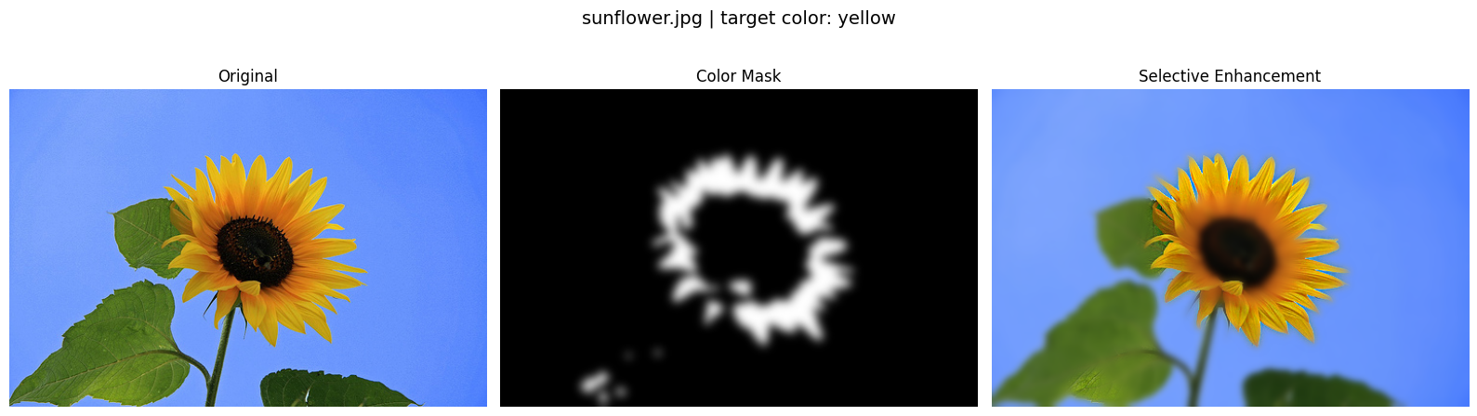
- The enhancement produces smoother and more natural transitions because of soft mask blending.

Task 2: Comparative Study of Sharpening Pipelines for X-Ray Images

1. Task Description
- The objective is to design and implement three independent image enhancement strategies (pipelines) specifically tailored for X-ray images. X-rays often suffer from low contrast and soft edges; the goal is to improve the visibility of fine structures (e.g., ribs, tissues) and provide a quantitative comparison of the results.

2. Method Used
- Pipeline 1 (Unsharp Masking): Reuses the sharpen_image logic from Task 1. It subtracts a blurred version of the image from the original to isolate high-frequency details, which are then added back to the image.
- Pipeline 2 (Laplacian-Based Enhancement): Uses a second-order derivative (Laplacian kernel) to detect sharp intensity transitions. This "edge map" is added to the original image to accentuate boundaries.
- Pipeline 3 (Hybrid Sobel & CLAHE): A sophisticated approach that combines gradient-based edge detection (Sobel) with local contrast enhancement. It injects high-frequency gradients into a CLAHE-processed base to ensure both local detail and global contrast are optimized.
- Evaluation: Results are compared using PSNR (Signal-to-Noise Ratio), SSIM (Structural Similarity), and Edge Strength Gain.

3. Implemented Functions Summary
- pipeline_unsharp_masking()
  - Performs traditional sharpening by creating a high-pass mask.
  - Goal: Quick, effective sharpening of broad details.
- pipeline_laplacian_sharpening()
  - Calculates the Laplacian of the image using a $3 \times 3$ kernel from ScratchLib.
  - Goal: To specifically target and enhance fine lines and point-like features.
- pipeline_high_frequency_injection()
  - Combines Sobel edge detection with CLAHE.
  - Goal: To prevent the "washing out" of details in overexposed or underexposed areas of the X-ray.
- run_comparative_study()
  - Executes all three pipelines on a single input image.
  - Calculates metrics for each and generates a comparative visualization.
- display_study_results()
  - Renders a grid showing the Original, Pipeline 1, Pipeline 2, and Pipeline 3 outputs side-by-side for visual inspection.

4. Results
- Visual Clarity: Pipeline 3 (Hybrid) typically provides the best balance, making lung vessels and bone edges distinct without introducing significant noise.
- Quantitative Performance: Pipeline 1 usually maintains higher PSNR (less distortion), while Pipeline 2 and 3 show higher Edge Strength Gain, indicating a sharper anatomical profile.
- Conclusion: Different pipelines are suitable for different diagnostic needs; Laplacian is better for fine fractures, while CLAHE-based injection is superior for soft tissue contrast.

